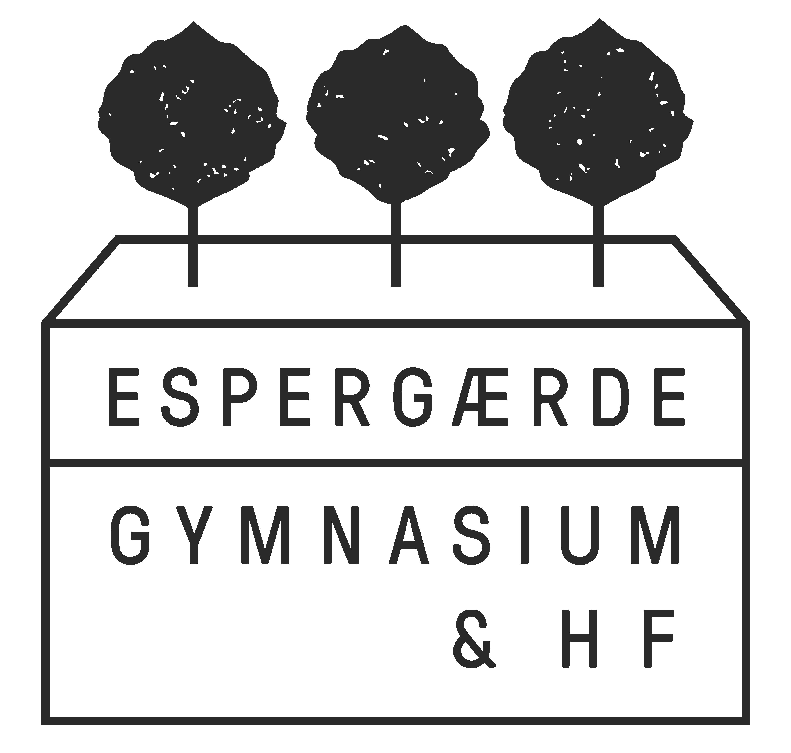

TRÆFFETIDER

Studievejledningen

Forår 2025

|  |  |  |  |  |  |  |  |  |  |  |
| --- | --- | --- | --- | --- | --- | --- | --- | --- | --- | --- |
|  | **MANDAG** | | **TIRSDAG** | | **ONSDAG** | | **TORSDAG** | | **FREDAG** | |
| **TID** | U-uge | L-uge | U-uge | L-uge | U-uge | L-uge | U-uge | L-uge | U-uge | L-uge |
| **8.05-**  **9.40** |  |  |  | **TO** |  |  |  |  |  |  |
| **10.00-11.35** | **LL** | **LL/FS** | **Møde** | **Møde med ledelse** | **MH/LL** |  | **TO** | **MH/CR/LL** | **TD/FS** | **FS** |
| **12.05-13.40** |  |  | **FS/CR/ TO** | TD/CR/ MH | **TD/CR** |  |  | **TO** | **MH** | TD |
| **13.50-**  **15.25** |  |  |  |  |  |  |  |  |  |  |

Frederik Sandby (FS): 1a, 1n, 2f, 2j, 2n, 3j, 3m

Mette Holm (MH): 1c, 1j, 1m, 2p, 2e, 2m, 3c, 3t

Lea Lavtsen (LL): 1t, 1e, 1q, 2c, 2u, 3k, 3u, 3b

Trine Døssing (TD): 1b, 1k, 1r, 2b, 2l, 2k, 3f, 3l

Torsten Jøhncke (TO): 1d, 1p, 2v, 2d, 2q, 3e, 3n, 3d

Charlotte Ryberg (CR): 1f, 1l, 1u, 2.a, 2.t, 3.a

TEAM DK: Mette (MH)

HEA-vejleder: Pernille Vedel Vincent (PE)